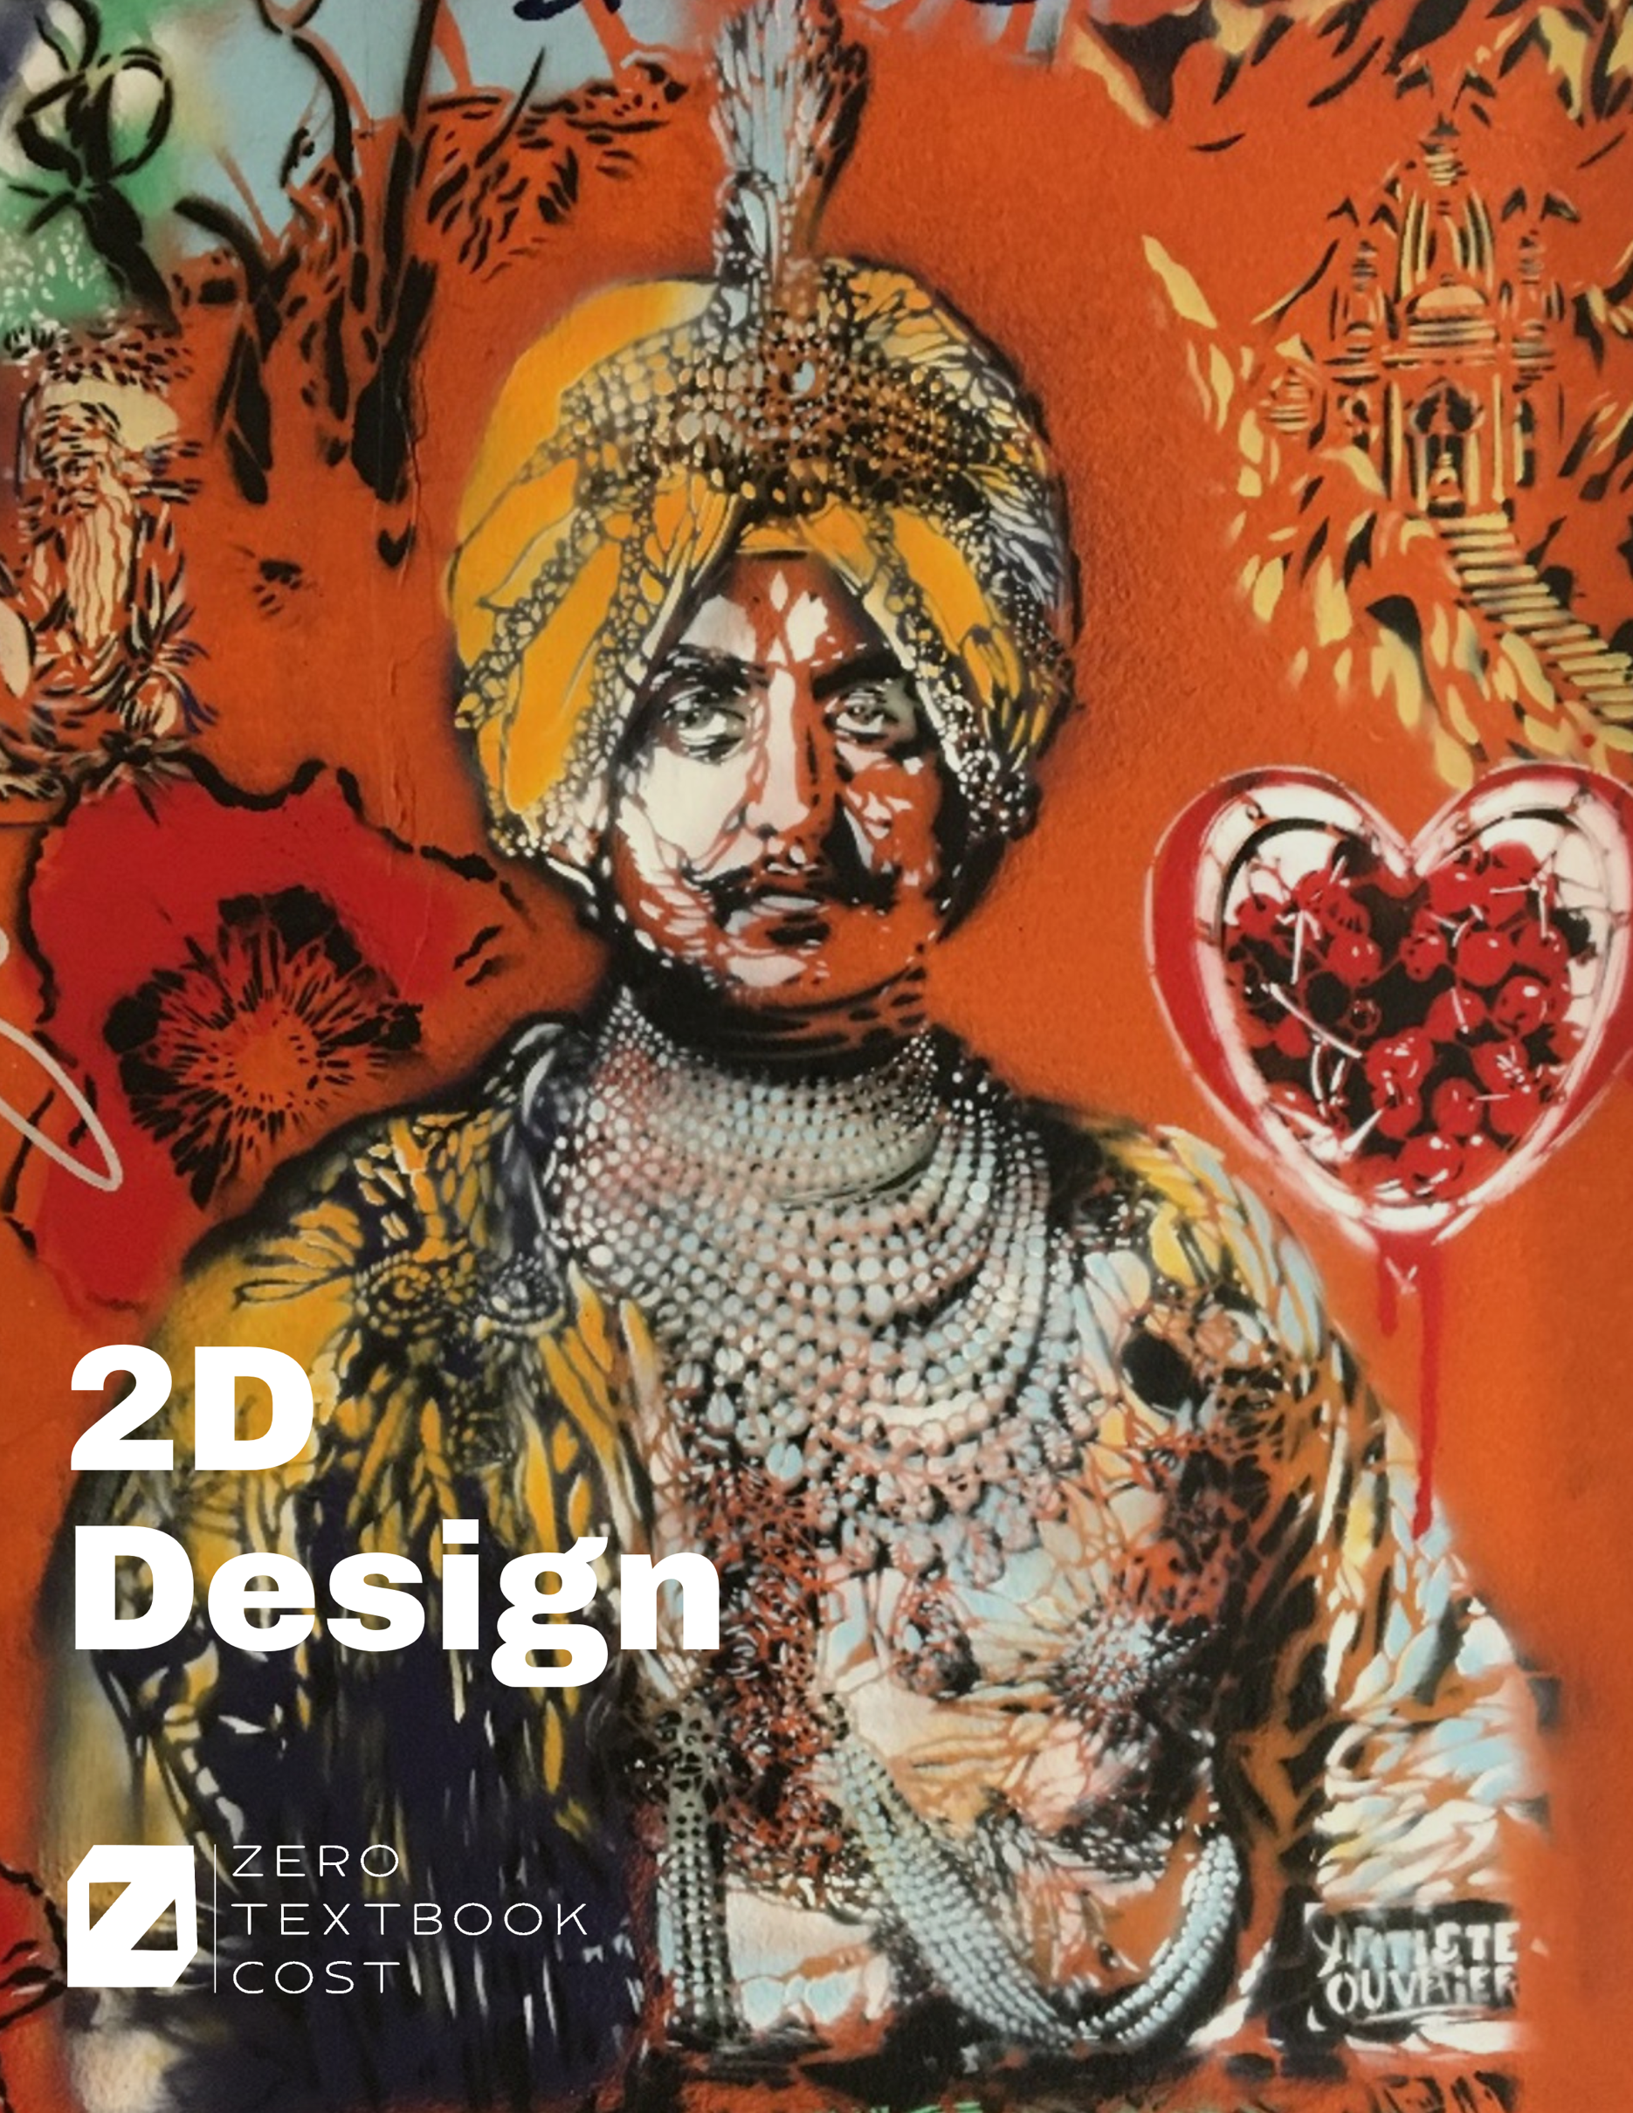

2D Design Studio Handbook

An Open Educational Resources Publication by West Hills College Lemoore in collaboration with College of the Canyons

Original Text by Fred Herbst, SUNY-CCC Professor of Art

Adapted by David Brooks, West Hills College Lemoore

Edited by Alex Gavilan, Lauren Fiero, and Kyra Karatsu
Cover Image by David Brooks
Cover Design by Lauren Fiero

Version 1.0

2024

The contents of this textbook were developed under an Open Textbooks Pilot grant from the Fund for the Improvement of Postsecondary Education (FIPSE), U.S. Department of Education. However, those contents do not necessarily represent the policy of the Department of Education, and you should not assume endorsement by the Federal Government.

The content in this textbook is licensed under CC BY-SA 4.0.


Table of Contents
2D Design Studio Handbook 2
Chapter 1: Studio Introduction 4
Studio Policies and Procedures 4
Safety Information 4
Chapter 2: Introduction to 2D Art Making 5
Critique/Crit 6
Sketchbook 7
Chapter 3: Art Elements 8
Elements of Art and Design as They Apply to 2D Artworks 8
Chapter 4: Art Principles 28
Organizing Art Elements 28
Visual Arts Glossary 36
Resources 47

Chapter 1: Studio Introduction

Studio Policies and Procedures
Please follow these rules during your time in class and during open studio access.
- Bring your tools and studio manual with you each class and/ or work session. Some projects will fit inside assigned cabinets to store between classes, but you may need to take larger pieces with you.
- You need to clean up your own mess. You are expected to put your projects away, clean your table, tools, etc. All paper and cardboard scraps need to be recycled. Any tools, materials, or projects left out may be thrown away.
- Always label your work so there is no confusion about who it belongs to.
- Do not cut directly on the wood tabletops. Always use a cutting mat or make your own out of recyclable cardboard sheets.
- Make sure to change blades in your X-acto knife often. Old, dull blades should be wrapped in masking tape and placed in the container next to the light table.

Safety Information
Every art making process has its own safety concerns. In 2D Design, the main issues include dust inhalation, cuts from X-acto and utility knives. Proper use of dust masks or respirators and good ventilation will minimize this exposure and help to ensure healthy conditions.

We will use a variety of tools. As needed, you should wear safety glasses, ear protection, and dust masks. If have long hair, always tie it back away from tools and equipment, always know where your hands are, what you're breathing, what's protecting your eyes and ears, and where the hot things are. Having an awareness and using logical steps toward safety will ensure a long career in art making.

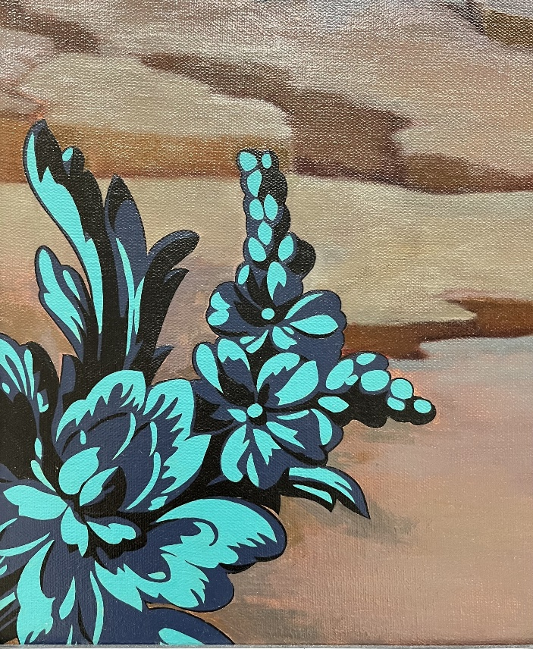
Figure 2.1: Detail from Femme Piquée par un Serpent by Kehinde Wiley.

Chapter 2: Introduction to 2D Art Making

From the beginning of our species, humans have been object makers. The first things made were items for survival (tools, weapons, and clothing) or for spiritual use (representations of animals or gods). As human cultures evolved, the kinds of objects also evolved to serve a vast range of purposes and functions. We are on that evolutionary makers continuum as we make things that are relevant to contemporary culture.

This course deals with the construction of 2D objects. One major difference between this way of creating artwork is that it takes place on a flat plane and only gives the illusion of physical depth and material texture. It tries to create the illusion of space. The objects illustrated do not take up 3D space with the viewer and often only see limited sides or points of view.

At its core, art and design are about communication. The goal is to communicate with the viewer or user. There are three components to any work that can be examined to see how well it communicates to the viewer. They are:
- Subject: [What] this is what is being presented. Is the object meant to be representational of something, non-representational but an abstraction of something, or conceptual (where the idea becomes the subject)?
- Form: [How] this is the overall arrangement or organization of the work. This uses the elements (building blocks/words) and principles (organizing elements into relationships/sentences) of art to build the work.
- Context: [Why] this is the emotional I intellectual message of the work. The context is the artist's intention and the message they are trying to get to the viewer.

The challenge of making interesting 2d subjects and ideas is a complex and rewarding process. Breaking down the basics and building up an effective art making process will be discussed in the rest of the studio handbook.

Critique/Crit
Individual and group evaluations of art works (critiques) are key to learning in the studio art environment. This experience will help you to see where your projects are successful, or where they might need improvement. You will also discuss other students' work in the same manner. The critique process should be one of constructive criticism that in the end, helps you make better decisions about your work and become a stronger visual artist. It is not a process used to give everyone a "pat on the back" just for showing up or as a way to put others down. The critique should be about the work that is being discussed separate from the maker. Every object I artwork ever made could be better somehow and the goal of the critique process is to discover how the works could be more effective and interesting.

Effectively presenting your ideas, projects, or objects to a group is a skill that matures with experience and has a great deal of value outside the college art studio. The critique process should help you develop your confidence in speaking about your ideas, receiving criticism, and responding appropriately. These are skills that should serve you well in your future career, whatever that may be.

In this studio course, we will look at your projects and discuss any relevant issues. Some of these aspects include how well your work fits the assigned criteria, how visually dynamic your solutions are, how interesting your concept is, and how well-crafted your objects are. Sometimes a piece will be strong in some of these areas but not in others. For example, a work might have an exciting idea behind it, but it is poorly constructed and is falling apart. Or another might be extremely well crafted but the idea behind the project is weak. The best works always have a balance of ideas, visual interest, and careful construction. We will use critiques to help you see where your work is strong and where it needs to continue to improve.

There are a several of questions to ask when analyzing an artwork in a studio art class. For example, did the maker use the required materials and techniques skillfully?
Does the piece work as a successfully integrated object or are there parts that don't fit? Did the artist use the elements and principles of art in the work effectively?
If the work is meant to be functional, does the piece make you want to pick it up and use it?

There are a number of questions to ask when interpreting an artwork in a studio art class. For example, what is your response to the piece?
How does it make you feel; does it make you think of anything from your own experience? Can you tell what the artist was trying to communicate to the viewer/ user?

There are many questions to ask when judging an artwork in a studio art class. For example, if you think the piece is successful, why do you feel that way? What are the work’s strengths and what could be done to make it more successful? What would the maker want to do over? What would be the next idea in a series of these kinds of pieces?

Critiques should be a valuable experience for all involved. Carefully looking at, thinking about, and discussing the works will help to make everyone a better artist. Remember, everything could be better somehow!

Sketchbook
The artist’s sketchbook is a critical tool in the development of their work. It is the location to sketch ideas, take notes, and plan the next steps in work production. Most artists carry a sketchbook (or something that functions like it) in their daily lives in order to capture ideas before they are forgotten. In studio classes, professors will ask you to make sketches of your ideas for projects before you begin. This will allow both you and the professor a chance to look at the design idea and discuss any issues that may come up during construction. Having something on paper to share makes this process possible and the most effective.

BLANK PAGES
Use blank pages in the handbook for notes and sketches: In addition, these pages can be used to paste required images.

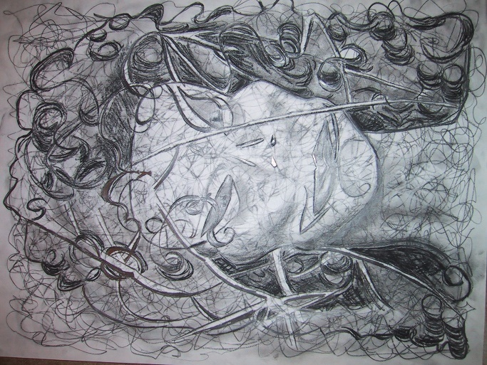
Figure 3.1: Sketch by David Brooks.

Chapter 3: Art Elements

Elements of Art and Design as They Apply to 2D Artworks

LINE
Line is the most familiar of art elements because it is used every day in basic communication. Our handwritten language is made of lines and symbols created using pencil or ink. When asked to depict something by drawing, lines are used to create that image on a 2D surface. Line is essential to communication and image making on a flat surface.

Figure 3.2: The Centre Pompidou in Paris, France has linear elements making up the exterior of the structure.

A line is a point that has been stretched for a distance. Lines do not occur in our three-dimensional reality, but our eyes create the line because of differences in shape, value, texture, and other factors. This also shows how line can interact with the other elements of art to create compelling 2d subjects. Linear (line like) elements often direct the viewer’s eye around an artwork since our eyes like to follow a "path" (also known as directional force).

As an element of art, line has a variety of characteristics that can be identified and utilized. The first is direction. These directions include horizontal, vertical, and diagonal. The direction of lines can imply feeling and meaning to the artwork. Horizontal lines suggest resting, passive or reclining forms. Vertical lines often make the object feel like they are reaching, growing up, or stretching. Diagonal lines are usually the most visually interesting. They often appear active, dynamic, and in motion.

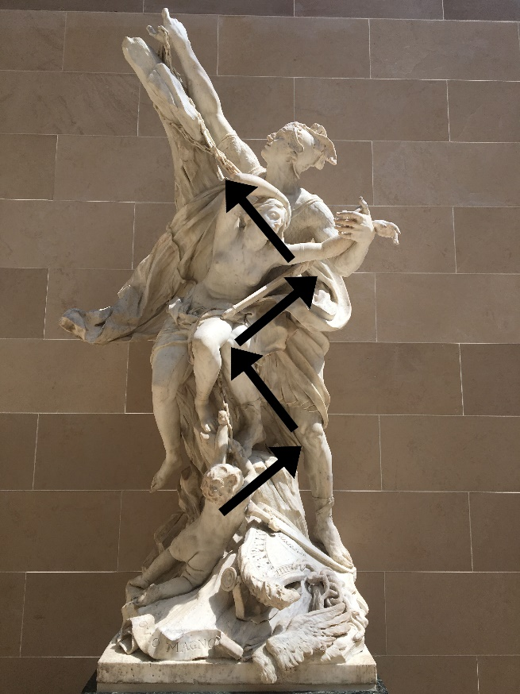
Figure 3.3: Photograph of Sculpture.

In addition to direction, line also has characteristics that could include the following: straight, curved, wavy, broken, implied (your eye completes the line without the line being there), angular, thick, thin. These terms are often discussed in drawing.


Figure 3.4: “Nelly” by Mark di Suvero.

This steel sculpture contains a variety of diagonal elements that create a more dynamic structure.


Figure 3.5: “Storm King Wall” by Andy Goldsworthy.

This stone wall snakes its way through the trees at Storm King Art Center.

Geometric & Organic Line Series
For this exercise, you will create a series of found geometric line compositions using the real world around you as inspiration. These lines can include geometric architectural lines found in buildings; or organic lines found in nature such as the vein lines on leaves. When drawing each, focus on the interior lines of the object(s) themselves.

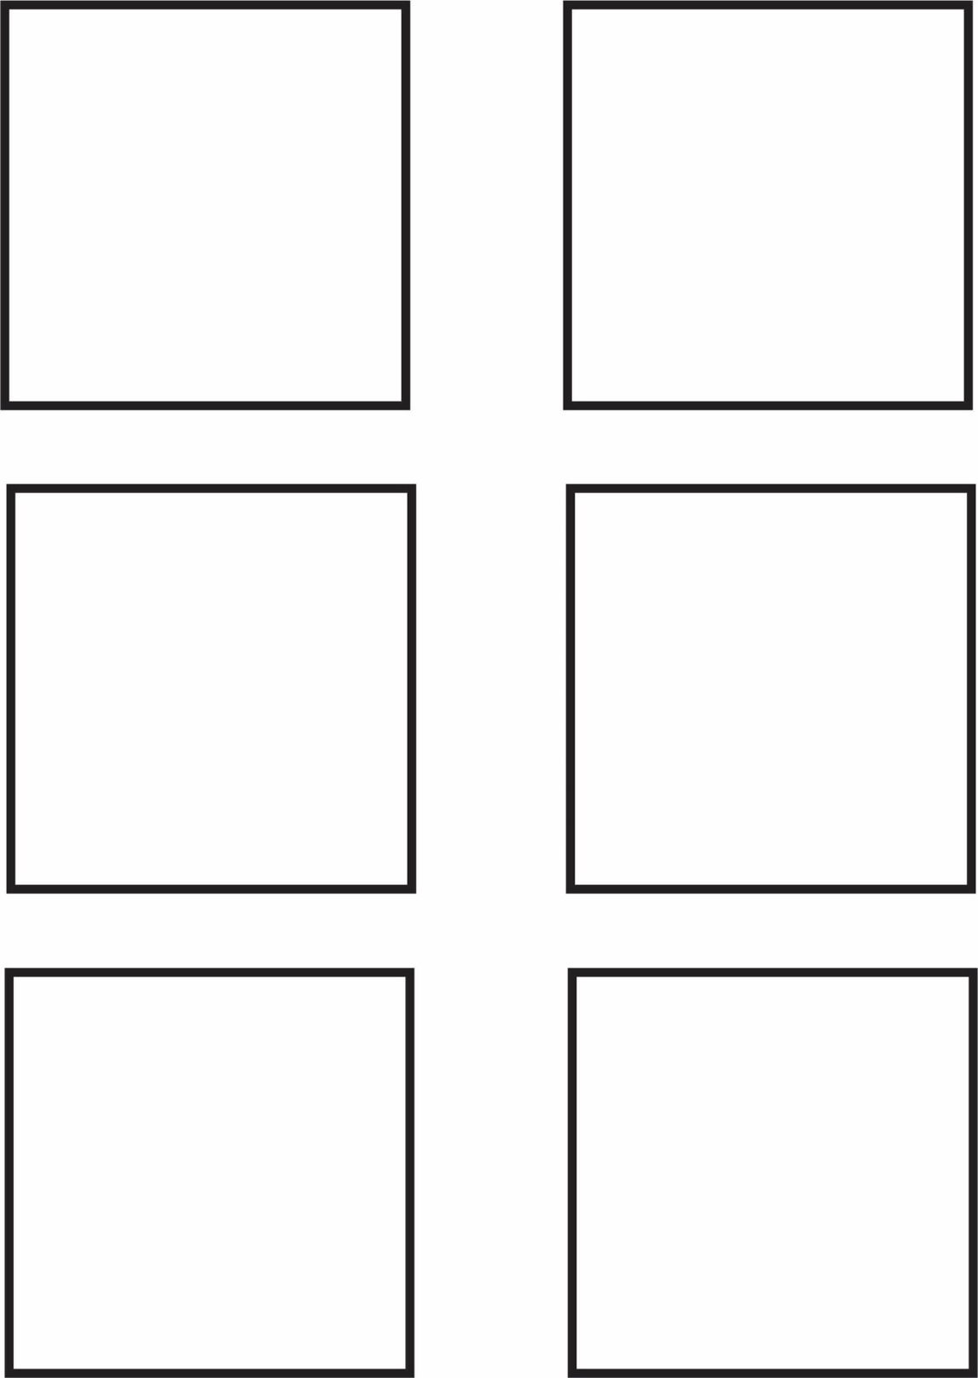

Emotional Series
For this exercise, create a series of emotional line compositions that deal with the notion of your feelings. These lines should focus on your internal emotions and how to express them through line. Remember a line is a dot moving through space, so how would that line move through space if you were feeling angry, sad, happy, etc. Complete the rest of the boxes with other types of emotions, be sure to label each box.

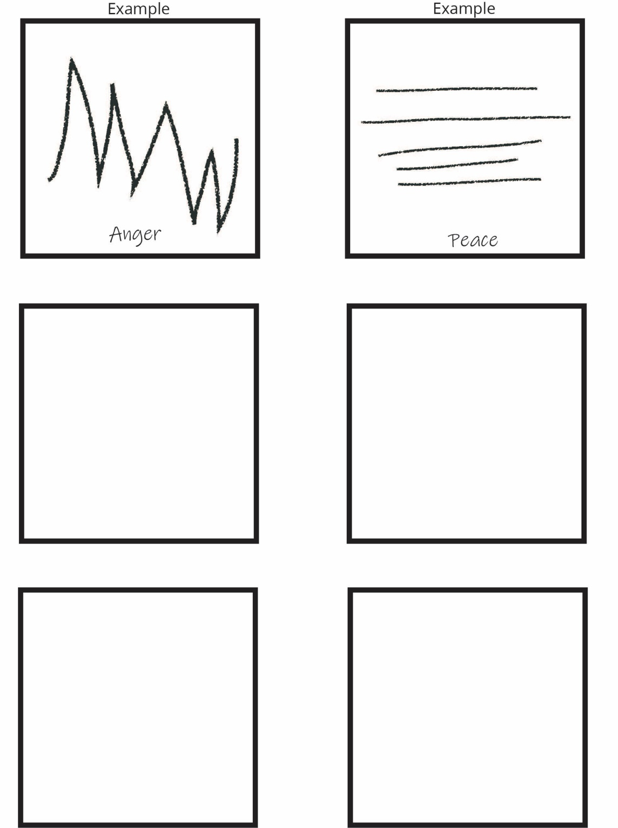

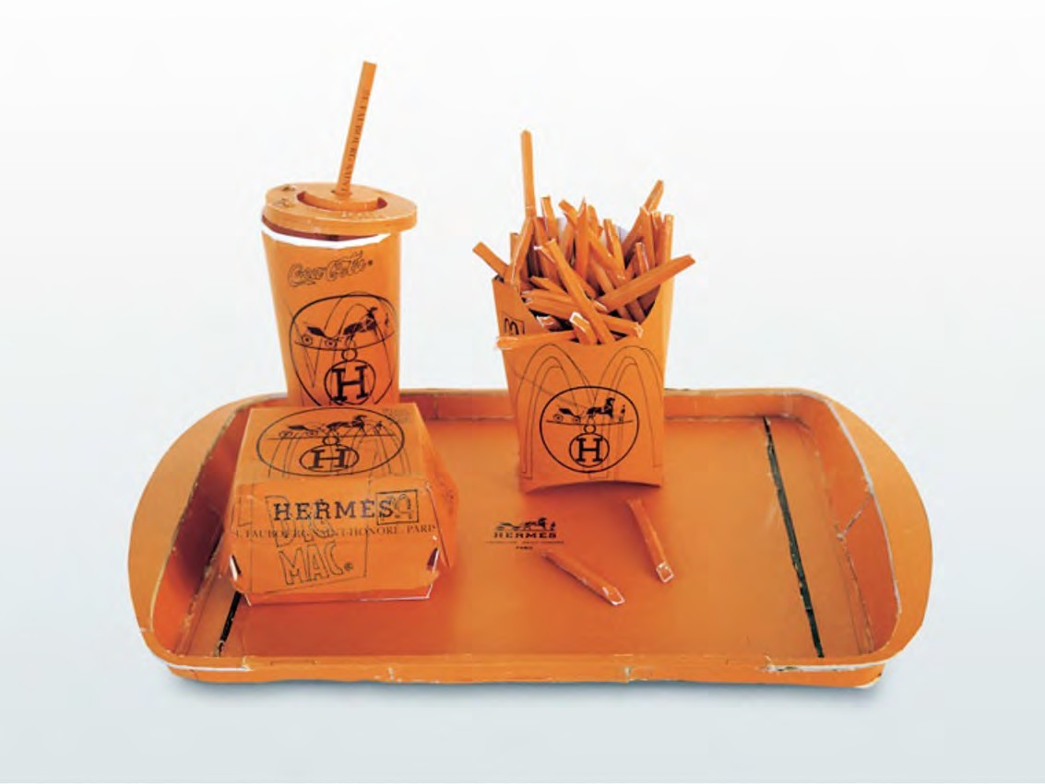
Figure 3.6: Tom Sachs “Hermes Value Meal.”

SHAPE (PLANE)
Shape is an area that stands out from the space next to or around it due to a defined or implied boundary often due to differences in value, texture, or color.

Just like line, shapes have a variety of possible characteristics. One of the most basic is the difference between being geometric or organic in nature. Geometric 2D shapes are typically made by humans and are made up of circles, squares, and triangles. Geometric shapes are derived from mathematics and can be curvilinear (made from curves) or rectilinear (made of straight lines).

In contrast, organic or biomorphic shapes are those generally found in nature. These shapes often have rounded, curving forms suggesting natural processes like growth, erosion, or decay. Humans are organic shapes and have worked with natural materials to create new forms over the history of our species.


Figure 3.7: Leaves with Organic shapes.

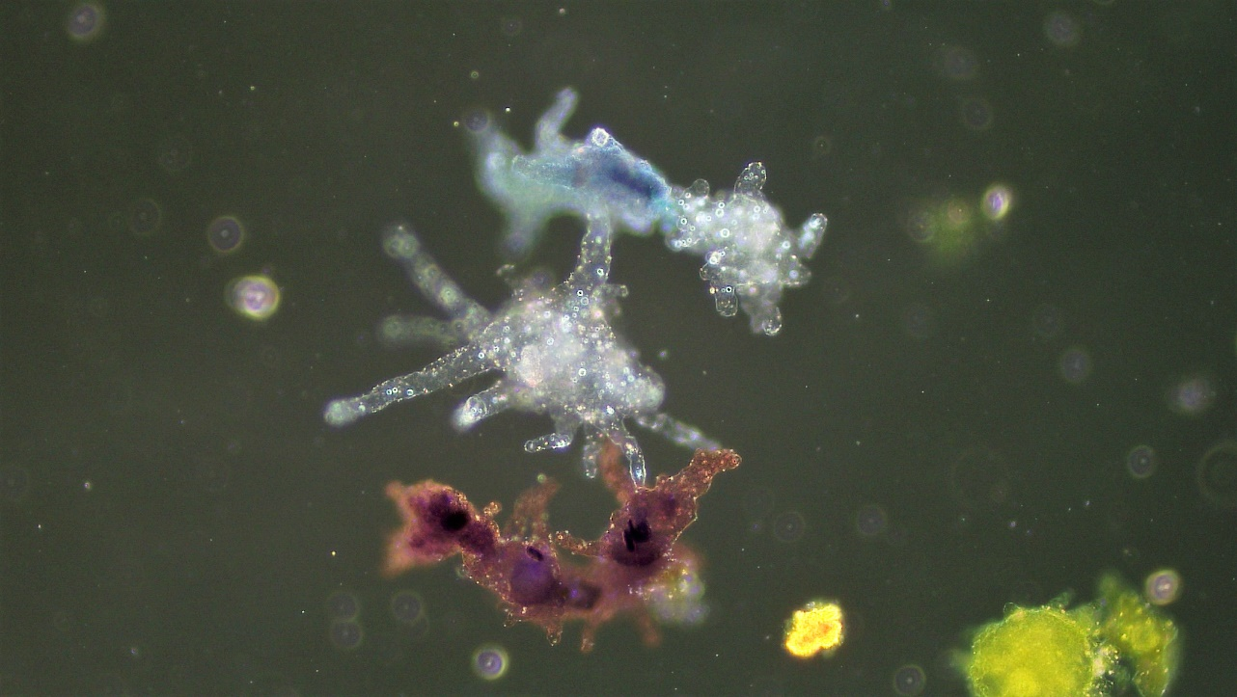
Figure 3.8: Amoeba Biomorphic Shape.

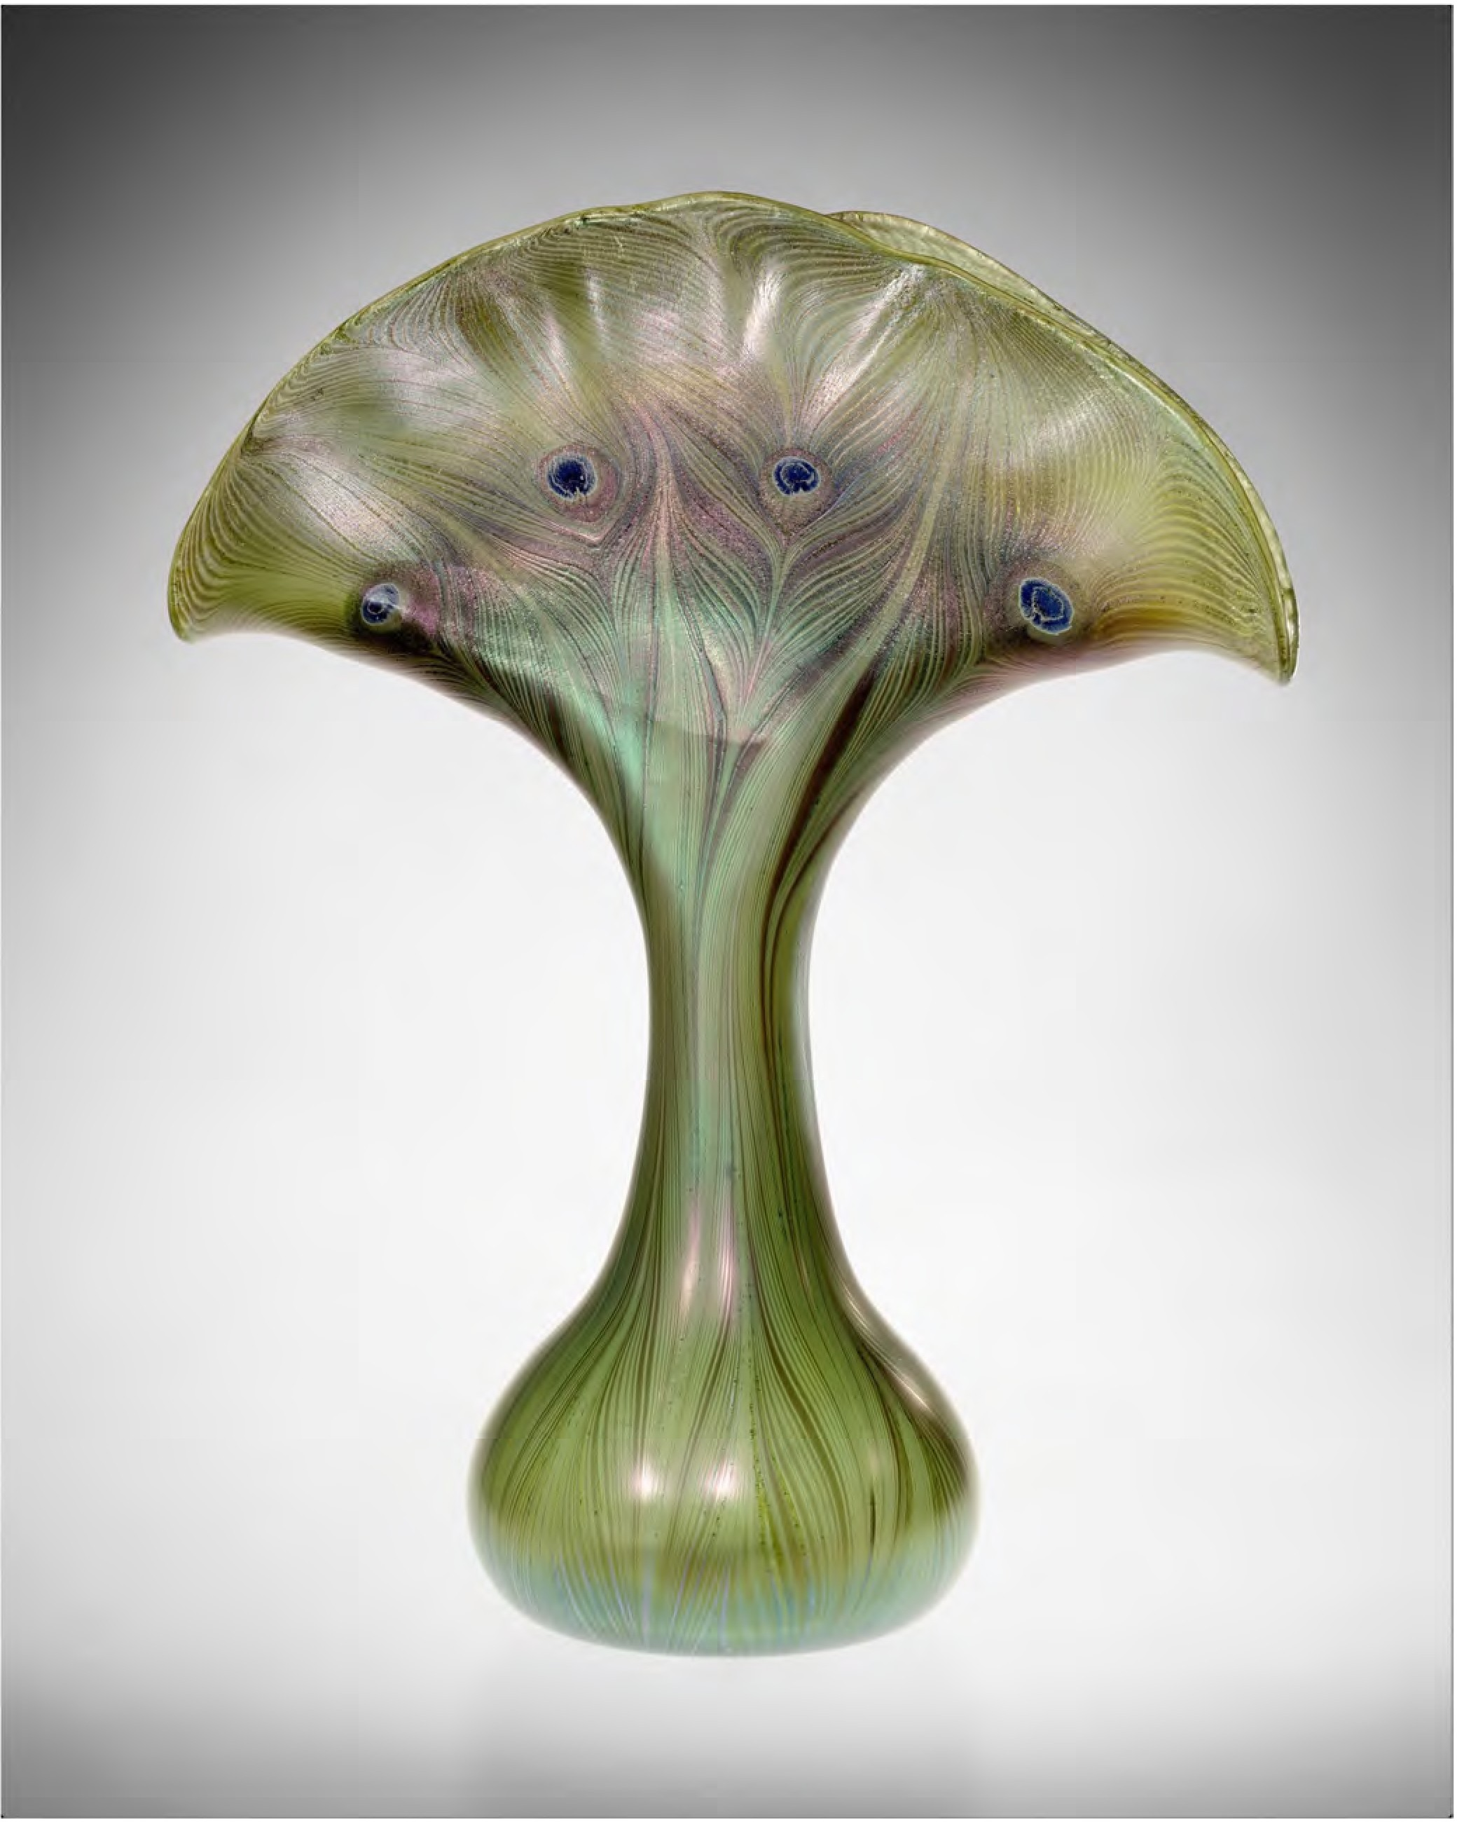
Figure 3.9: “Vase”, by Louis Comfort Tiffany, 1893-96, made of blown Favrile glass.

Tiffany was looking to create a very organic form in both the shape, color, and pattern in the surface of this vase.

Another important characteristic when discussing shape is the difference between mass and volume. In 2D design, mass and volume are implied, the illusion made by using shading to add value. Mass is defined as the physical weight of an object. Stone, clay, plaster, concrete, and metal objects generally appear to have a large mass.

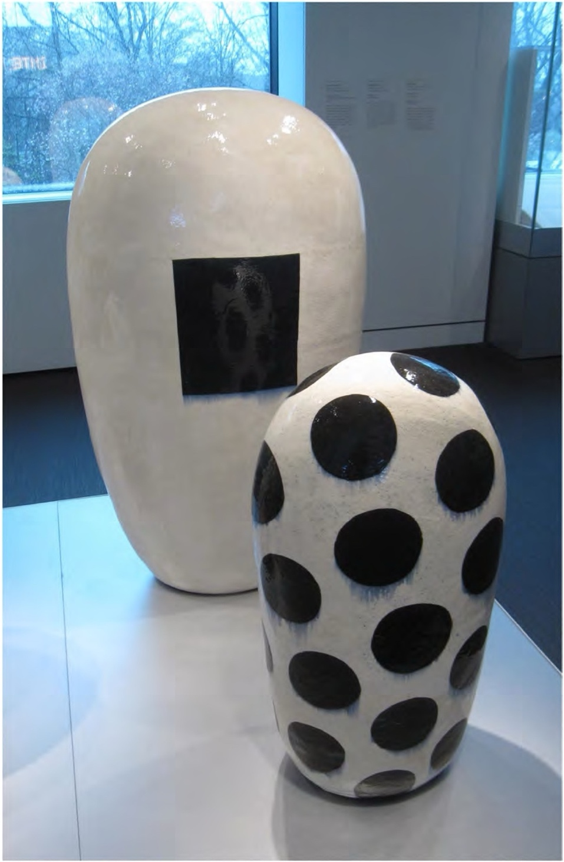
Figure 3.10: Two ”Dango” sculptures by Jun Kaneko made of glazed ceramic.

These pieces were constructed hollow in order to survive the kiln firing process but still have considerable visual mass.
Volume is how much space an object occupies. A massive shape generally takes up a large amount of space, but a lighter object can also have the same volume and occupy the same amount of space. This concept can be simplified to: All mass has volume, but not all volume has mass.

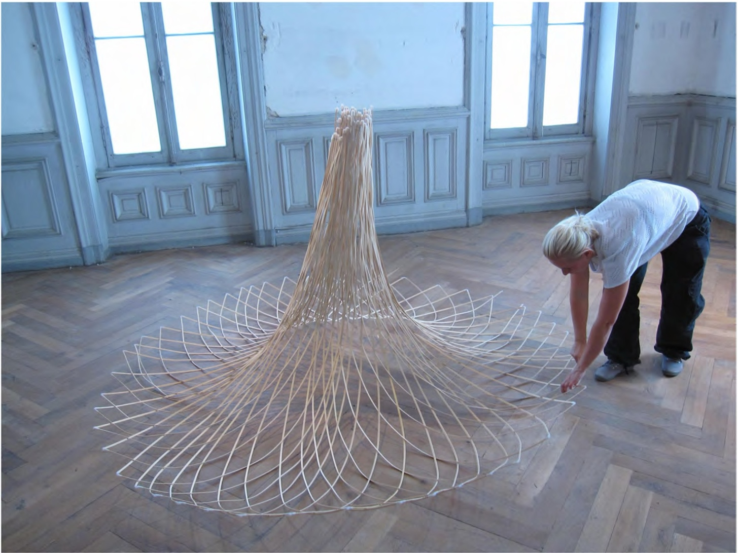
Figure 3.11: This bamboo structure has a relatively large volume but very little physical weight or mass.

SPACE
Space is the area in or around objects. In 2D art and design, we are trying to create the illusion of space on a flat surface since there is no actual physical space, we are constructing in. There are a few important considerations and aspects of space. The first is the positive/ negative space relationship.

Positive space is the area that the object takes up. It is the volume that the object you create fills. In contrast, negative space is the empty space around the object. The relationship between these two can create interesting visual tension as the viewer moves around and interacts with the object. Typically, darker shapes are seen as negative space shapes and lighter as viewed as positive.

There are cues that can add to the illusion of depth in an artwork. These cues include overlapping, size, and detail (texture), diminishing size, placement, perspective and

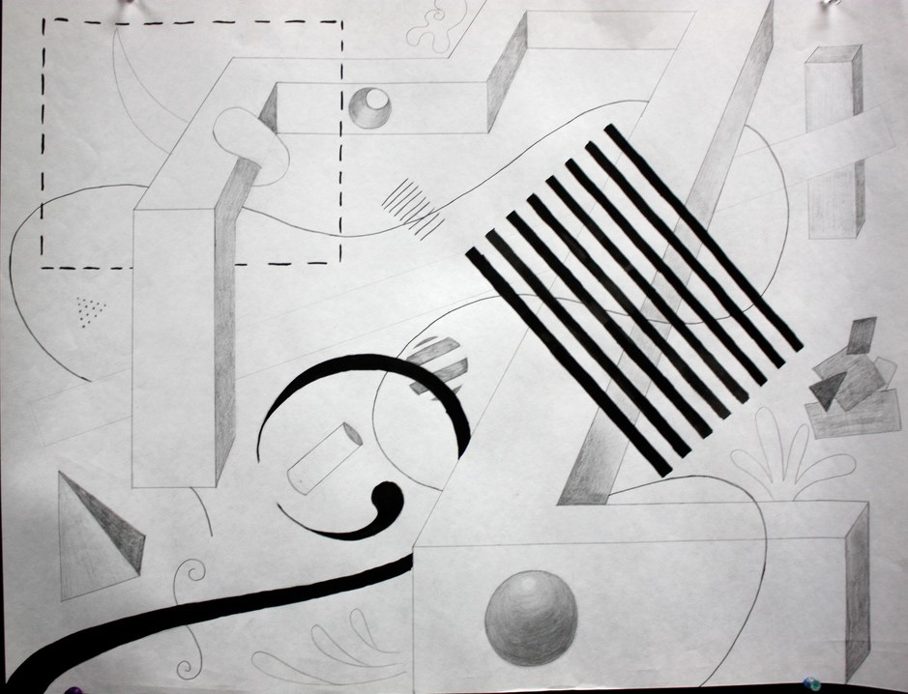
Figure 3.12: Drawing by David Brooks.

This composition uses line shape, and form with spatial depth cues of overlapping, diminishing size, and size relationships.

Use the following squares to recreate the positive and negative spaces in and around the objects

Original | Recreation
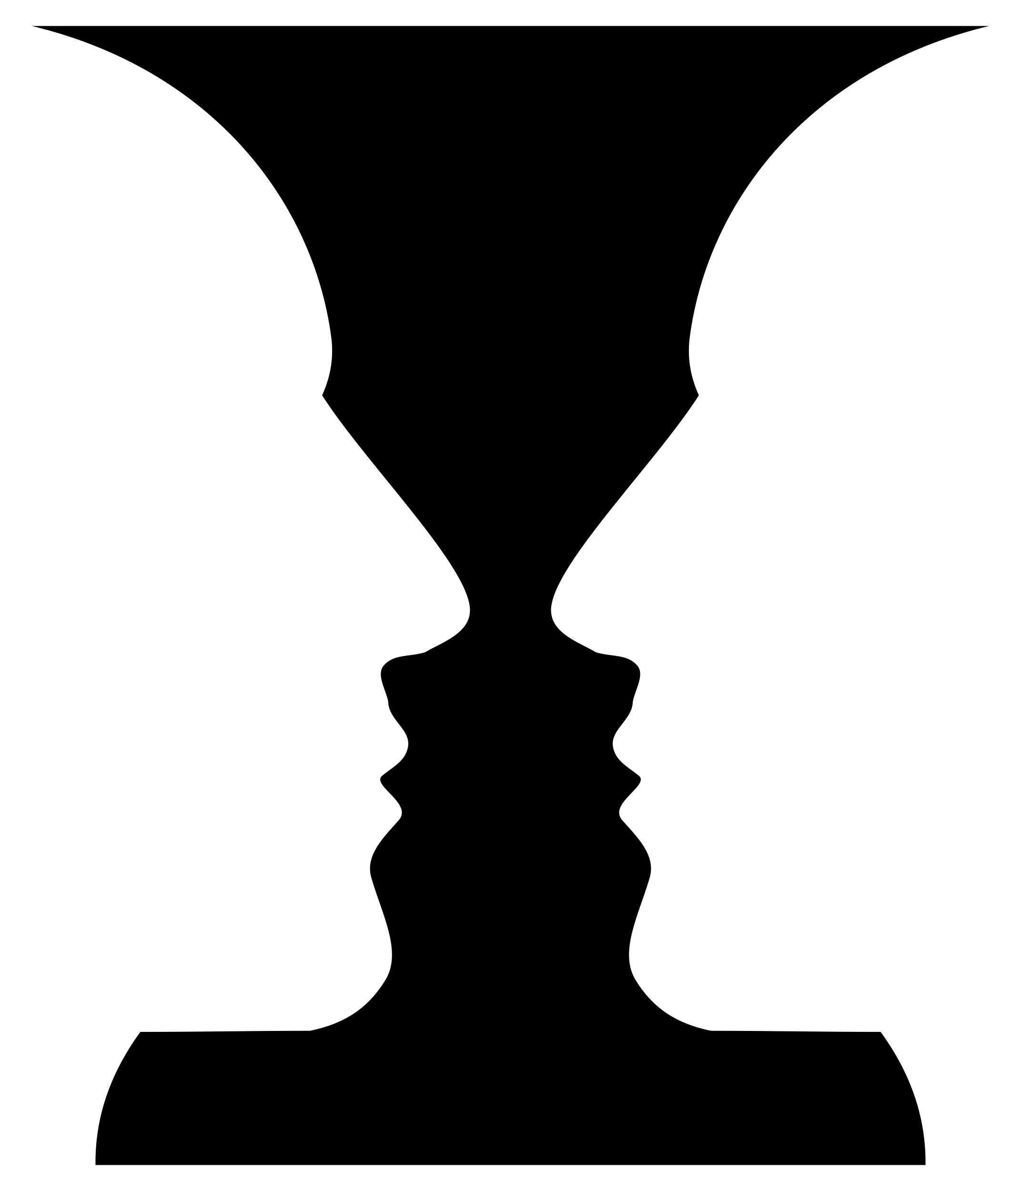
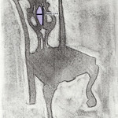
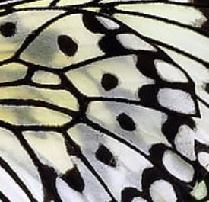

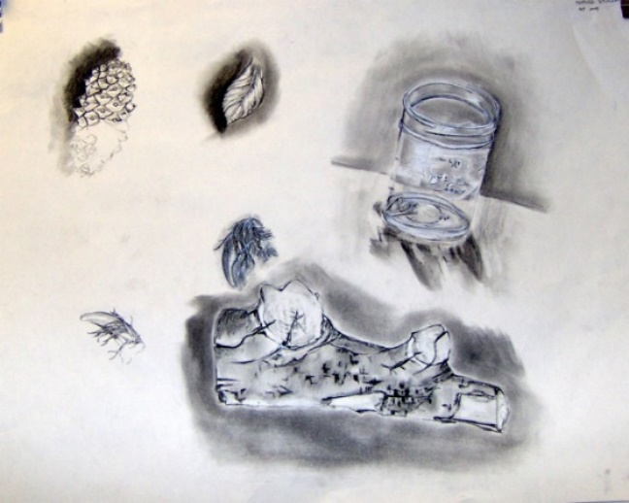
Figure 3.13: Drawing by David Brooks.

TEXTURE
Texture is the surface character of a material which can be experienced through touch or the illusion of touch. Surface texture can work differently depending on the purpose of the object. Functional objects (pottery, furniture, jewelry, fabrics, glass) that are meant to be handled, worn, or sat on need to have textures that be safe and appealing for the user. Textures can also be purely visual. As a result, they can be anything from the actual texture of the materials that make up the piece to invented textures trying to imitate something else.

In two-dimensional works, there are actual textures; ones you can actually touch and feel, and implied texture, or visual memories.

VALUE
Value is the relative degree of lightness or darkness of an object. There can be value considerations when dealing with surfaces and spaces in a work. Highly textured surfaces can be emphasized by the dramatic highlight and shadows on a piece. A matte surface will have a different value than a shiny surface of the same colour. In addition, dark colors can make a large piece appear smaller and light colours can make a small piece appear larger.

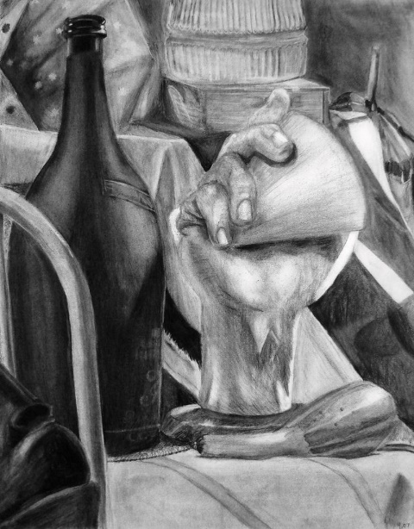
Figure 3.14: Still Life: Achromatic by nyxinc

Achromatic Value Chart
For this exercise, you will create a value scale with 9 values from black to white. This value scale will use acrylic paint and a piece of Bristol board cut into a swatch that measures a minimum of 1-inch by 9-inches. Follow the step-by-step instructions below:

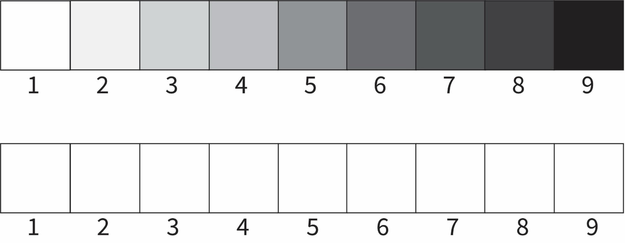

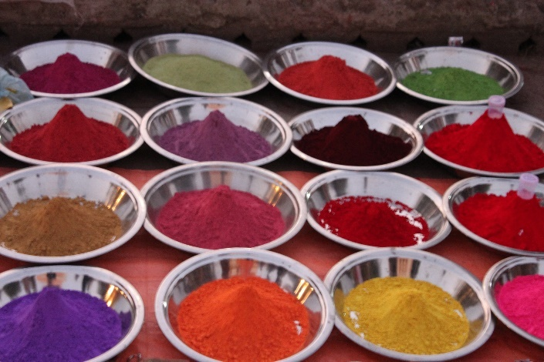
Figure 3.14: Photograph by David Brooks.

COLOUR
Colour is the eye's visual response to the wavelengths of light that can be identified as red, green, blue, and so on. Colour has important physical and cultural meaning that the artist can manipulate to make their work more appealing and powerful. Colour systems like Colour wheels were developed to help artists and designers understand and work with the relationships of colors such as primary, secondary, intermediate, complementary, and other combinations.

Colour is most often dealt with extensively in 2D art making. Using one or only a few colors on a complex shape can emphasize the complexity of that object. Using a variety of colours or complex patterns on a simple shape will do the same thing, create a more visually dynamic object.

Colour temperature (warm/cool) can also change how the viewer sees the work. Warmer colors (reds, yellows, oranges) seem active and closer to the viewer. Cooler colours (blues, greens, purples) are generally more subdued and recede away from the viewer. Using both kinds on one object will create interest that relates to colour relationships mentioned above.

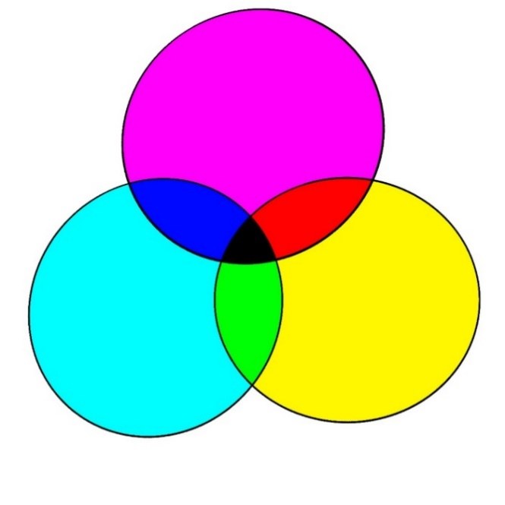
Figure 3.15: Example of subtractive Colour Chart.

A primary is a color that cannot be created by mixing two or more colors together but is instead used to create all other hues. The “traditional” primaries (Red, Yellow, Blue) were established in 1666 by Isaac Newton based on the limited natural pigments available during his time and place. Thanks to technological advancements in the production of synthetic pigments and printing practices, we now have a better understanding of color perception and color theory- these modern primaries still recognize yellow, but red has been replaced with magenta and blue has been replaced with cyan. Red cannot be a primary as it can be created by mixing magenta with yellow. Blue cannot be a primary as it can be created by mixing magenta into cyan. RBY cannot create hues similar to magenta or cyan.

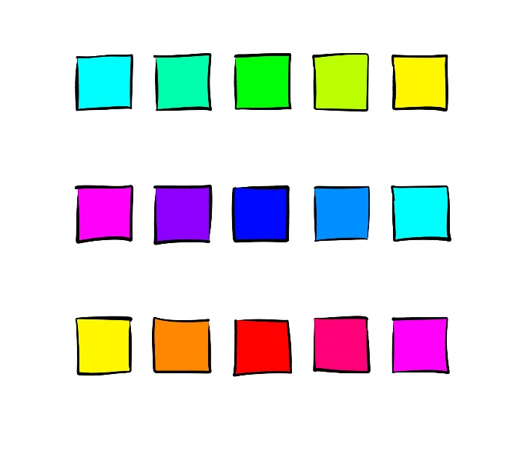
Figure 3.16: Example of CYM colour mixing chart.

The preferred pigments/paints for the closest replication of CMY color is quinacridone magenta, phthalo blue. I do not have strong opinions about yellow pigments as there are many vibrant yellow options, such as hansa.

Magenta + Yellow = Red

Cyan + Magenta = Blue

Yellow + Cyan = Green

This leaves us with secondaries of red, blue, and green- which also happen to be the additive primaries, establishing the inverse relationship between additive and subtractive color theory.

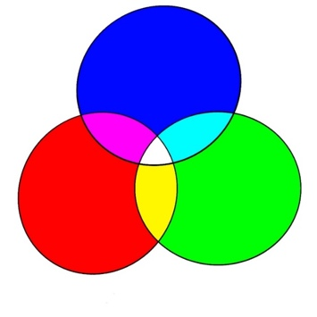
Figure 3.17: Example of Additive Colour Chart.

Colour
For this exercise, you will need to complete the following colour wheel. Follow the step-by-step instructions below:
Complete the Colour Wheel:

Mix the Following Combinations

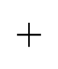
Red Yellow 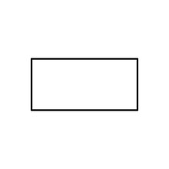

Red Blue

Yellow Blue

Complete the Following Colour Schemes:

Primary Colours  They make the other colours. | Secondary Colours  They are made by mixing primary colours.

Warm Colours  They make you think of warm things. | Cool Colours  They make you think of cool things.

Complementary Colours

They are opposites on the colour wheel.

Analogous Colours

They are close neighbors on the colour wheel.

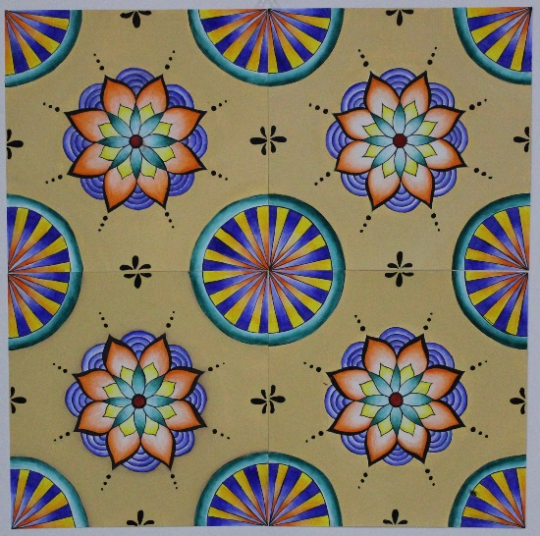
Figure 4.1: Artwork by a student.

Chapter 4: Art Principles

Organizing Art Elements
The principles of art are a way of organizing the art elements to make interesting images or objects. When looking at a work, we often generalize about how the principles are used to create a feeling or overall effect. You may also want to think about the elements of art as words and the principles are the sentences you can create in order to communicate your idea.

As you become a more experienced artist, the elements and principles of art will become a subconscious part of what you do. You will consider the entire artwork and make critically informed decisions about what would make it more aesthetically pleasing. Your personal approach to art making will evolve as you find new inspirations and build new technical skills.

BALANCE
Balance is the sense of visual equilibrium achieved through implied weight, attention, or attraction within an artwork. In 2D art and design, balance also applies to the physical construction of an artwork.

The three types of visual balance most often used are symmetrical, asymmetrical, and radial balance. An object has symmetry when it feels like all parts are a mirror image of the others, for example a round, straight sided cylinder. Asymmetry is when there is an uneven amount of visual weight on one side of the object.

The use of asymmetrical balance often creates more visually dynamic objects. Radial balance refers to a circular or wheel-like balance in the shape.

Here we see a symmetrically balanced composition that when divided down the middle is equal on both sides, a mirror image.

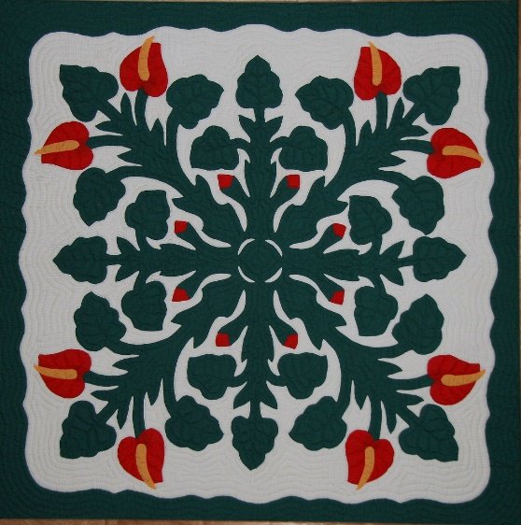
Figure 4.1: Symmetrical Balance.

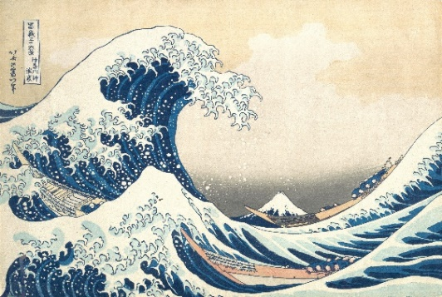
Figure 4.2: Asymmetrical Balance.

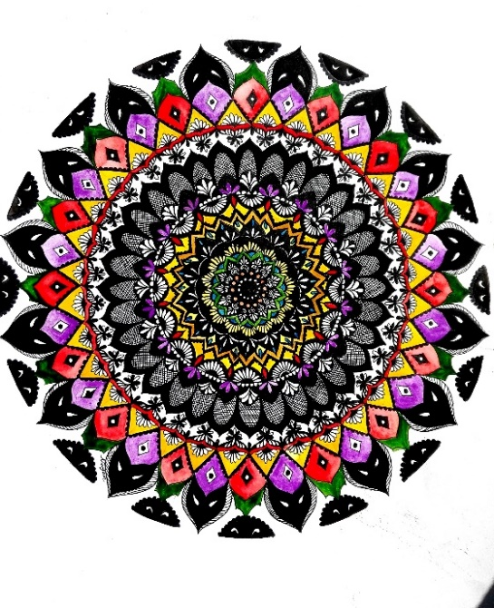
Figure 4.3: Radial Balance.

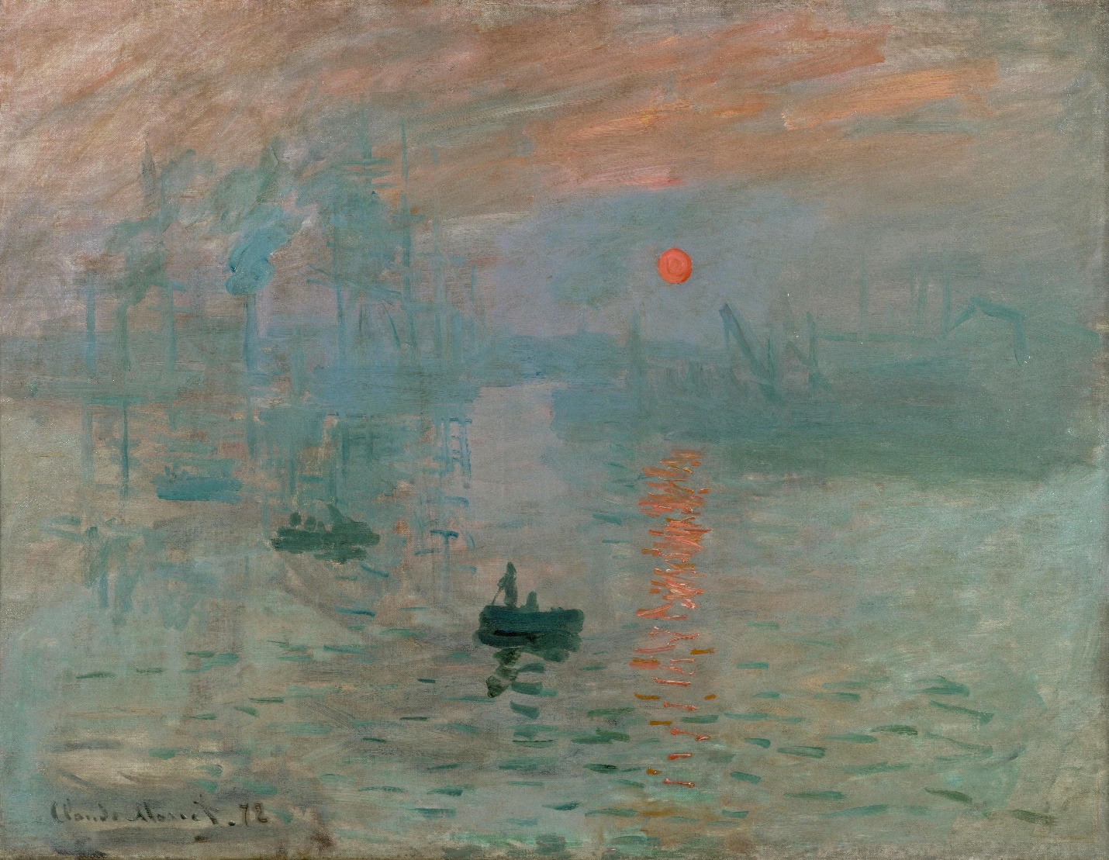
Figure 4.4: “Impression Sunrise” by Claude Monet 1872.

The Orange sun against the blue grey fog creates an area of emphasis.

EMPHASIS
Emphasis (also known as visual dominance) is the creation of visual importance through selective tension. Parts of the object are differentiated from the other parts to enhance attraction and interest.

There are many ways to achieve emphasis, including contrasting or exaggerating size, shape, value, color, and texture. Parts of the object can be used to point the viewers’ attention to the specific element the maker wants to emphasize. This is done through the largest most exciting, or dominant element.

PROPORTION AND SCALE
Proportion refers to the relative size of an element measured against other elements or against some norm or standard. Proportion often refers to a ratio of the size of parts to the whole. The "Golden Mean" was a proportional system developed by the ancient Greeks that helped create harmony in Western design. It was based on and can be seen in many forms found in nature.

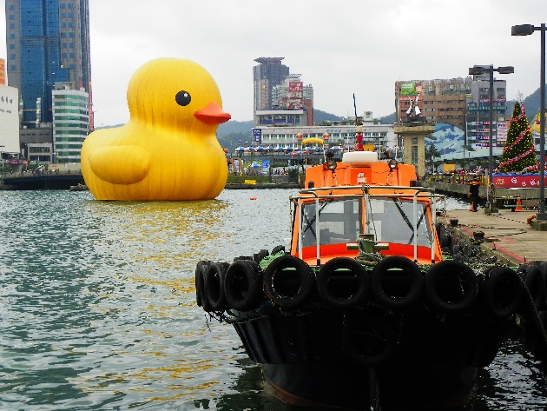
Figure 4.5: Proportion.

Scale can be another word for size in a work. Scaling can refer to changing the size of an image or object. A comment often heard during critique is that the object would be more interesting if it was a different scale (larger or smaller). As a species, humans relate everything to their own size (life-size, miniature, and monumental). Small things like insects are tiny to us but we are the size of buildings to them.

For much of art history, artists were attempting to define the "perfect" human proportion. The problem with that idea is that there is no such thing as perfect. The human body and its parts have varied across time and space and what is seen as "beautiful" or pleasing changes constantly. As a self-absorbed species, the human form has infinite interest to viewer and artists alike.

MOVEMENT
Movement (also known as directional force) is the direction and degree of energy implied by the art elements in specific compositional situations and directions. In 3d artworks, the element of actual movement is also possible.

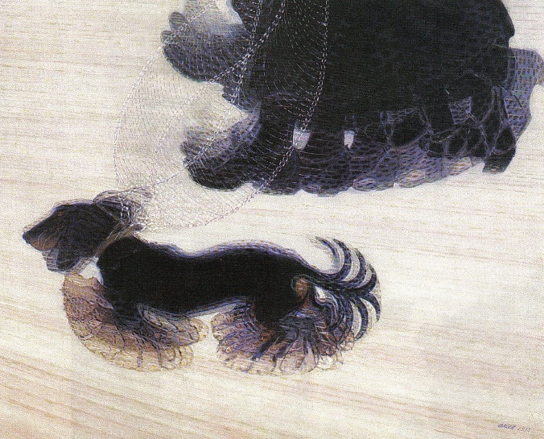
Figure 4.6: "Dynamism of a Dog on a Leash" by Giacomo Balla.

Ways to create movement can include lines, repeated figures, blurred outlines, illusions of growth, and multiple images. An object with implied movement creates the sense that the object has momentarily stopped but will continue. Some 3D artworks have implied movement as part of their concept.

UNITY
Unity (also known as harmony) is the presentation of an integrated image or object achieved through visual similarity (see repetition).

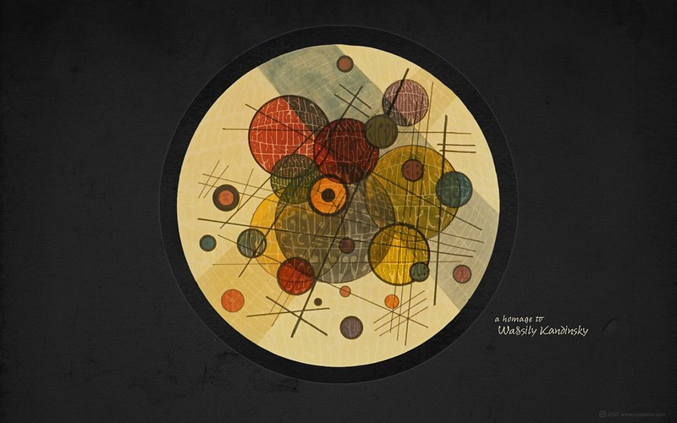
Figure 4.7: Homage to the Russian painter Wassily Kandinsky.

A few ways to achieve unity include proximity of parts, coordination of all elements toward one concept, repetition of the same element in decoration, or a rhythm of slightly changing details. Unity can also be achieved by introducing an element of variety in parts that add up to an interesting whole.

VARIETY
A principle of art concerned with combining one or more elements of art in diverse ways to create interest. Too much variety can leave a composition feeling chaotic. Not enough variety can make the composition boring.
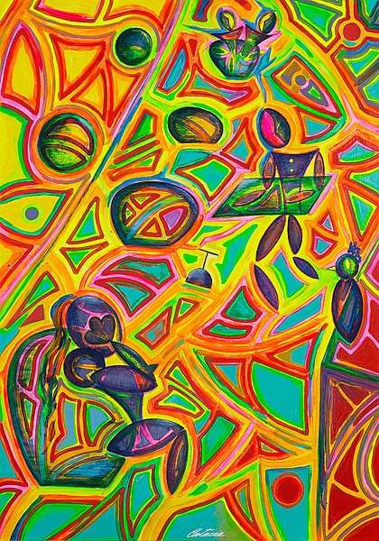
Figure 4.8: The Old Man sleeping on the Ship is an example of variety

RHYTHM / REPITION / PATTERN
Rhythm is the intentional, regular repetition of the elements of lines of shapes or colour to achieve a specific repetitious effect or pattern and unity in an artwork. Rhythm can also be achieved through pattern, an element repeated in a predictable combination. Rhythm is used to move the viewer through a work of art.

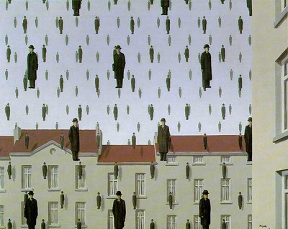
Figure 4.9: Golconda - René Magritte 1953

ECONOMY
Economy is the elimination of elaborate details leaving only the significant essentials of the object or installation. The goal is to pare it down without making the work monotonous. Economy is often associated with the term "abstraction" in which unnecessary elements are eliminated to show the essence of something.

Visual Arts Glossary
Abstract: Artwork in which the subject matter is stated in a brief, simplified manner. Little or no attempt is made to represent images realistically, and objects are often simplified or distorted.

Additive: Refers to the process of joining a series of parts together to create a sculpture; or the process of building up a drawing or 2D work through layering of media or materials.

Aerial perspective: Aerial or atmospheric perspective achieved by using bluer, lighter, and duller hues for distant objects in a two-dimensional work of art.

Aesthetics: A branch of philosophy; the study of art and theories about the nature and components of aesthetic experience.

Installation art: Art designed to exist in a site-specific location whether inside or outside, public, or private. Contemporary art installation materials can range from everyday objects and natural materials to new and alternative media. Often the viewer walks into the installation space and is surrounded by the art.

Analogous: Refers to closely related colors; a color scheme that combines several hues next to each other on the color wheel.

Appropriation: Intentional borrowing, copying, and alteration of preexisting images and objects.

Arbitrary colors: Colors selected and used without reference to those found in reality.

Art Criticism: An organized system for looking at the visual arts; a process of appraising what students should know and be able to do.

Art Elements: See elements of art.

Art: In everyday discussions and in the history of aesthetics, multiple (and sometimes contradictory) definitions of art have been proposed. In a classic article, “The Role of Theory in Aesthetics,” Morris Weitz (1956) recommended differentiating between classificatory (classifying) and honorific (honoring) definitions of art.

Artist statement: Information about context, explanations of process, descriptions of learning, related stories, reflections, or other details in a written or spoken format shared by the artist to extend and deepen understanding of his or her artwork; an artist statement can be didactic, descriptive, or reflective in nature.

Artistic investigations: In making art, forms of inquiry and exploration; through artistic investigation artists go beyond illustrating pre-existing ideas or following directions, and students generate fresh insights—new ways of seeing and knowing.

Art-making approaches: Diverse strategies and procedures by which artists initiate and pursue making a work.

Artwork: Artifact or action that has been put forward by an artist or other person as something to be experienced, interpreted, and appreciated.

Assemblage: A three-dimensional composition in which a collection of objects is unified in a sculptural work.

Asymmetry: A balance of parts on opposite sides of a perceived midline, giving the appearance of equal visual weight.

Atmospheric perspective: See aerial perspective.

Background: The part of the picture plane that seems to be farthest from the viewer.

Balance: The way in which the elements in visual arts are arranged to create a feeling of equilibrium in a work of art. The three types of balance are symmetry, asymmetry, and radial.

Brainstorm: Technique for the initial production of ideas or ways of solving a problem by an individual or group in which ideas are spontaneously contributed without critical comment or judgment.

Characteristic(s): Attribute, feature, property, or essential quality.

Characteristics of form (and structure): Terms drawn from traditional, modern, and contemporary sources that identify the range of attributes that can be used to describe works of art and design to aid students in.

Collaboratively: Joining with others in attentive participation in an activity of imagining, exploring, and/or making.

Collage: An artistic composition made of various materials (e.g., paper, cloth, or wood) glued on a surface.

Color relationships: Also called color schemes or harmonies. They refer to the relationships of colors on the color wheel. Basic color schemes include monochromatic, analogous, and complementary.

Color: The visual sensation dependent on the reflection or absorption of light from a given surface. The three characteristics of color are hue, value, and intensity.

Color theory: An element of art. Color has three properties: hue, value, and intensity.

Complementary colors: Colors opposite one another on the color wheel. Red/green, blue/orange, and yellow/violet are examples of complementary colors.

Composition: The organization of elements in a work of art.

Concepts: Ideas, thoughts, schemata; art arising out of conceptual experimentation that emphasizes making meaning through ideas rather than through materiality or form.

Constructed environment: Human-made or modified spaces and places; art and design-related disciplines such as architecture, urban planning, interior design, game design, virtual environment, and landscape design shape the places in which people live, work, and play.

Contemporary artistic practice: Processes, techniques, media, procedures, behaviors, actions, and conceptual approaches by which an artist or designer makes work using methods that, though they may be based on traditional practices, reflect changing contextual, conceptual, aesthetic, material, and technical possibilities; examples include artwork made with appropriated images or materials, social practice artworks that involve the audience, performance art, new media works, installations, and artistic interventions in public spaces.

Contemporary criteria: Principles by which a work of art or design is understood and evaluated in contemporary contexts which, for example, include judging not necessarily on originality, but rather on how the work is re-contextualized to create new meanings.

Content: Message, idea, or feelings expressed in a work of art.

Context: Interrelated conditions surrounding the creation and experiencing of an artwork, including the artist, viewer/audiences, time, culture, presentation, and location of the artwork’s creation and reception.

Contour drawings: The drawing of an object as though the drawing tool is moving along all the edges and ridges of the form.

Contrast: Difference between two or more elements (e.g., value, color, texture) in a composition; juxtaposition of dissimilar elements in a work of art; also, the degree of difference between the lightest and darkest parts of a picture.

Cool colors: Colors suggesting coolness: blue, green, and violet.
Copyright: Form of protection grounded in the US Constitution and granted by law for original works of authorship fixed in a tangible medium of expression, covering both published and unpublished works.

Creative Commons: Copyright license templates that provide a simple, standardized way to give the public permission to share and use creative work on conditions of the maker’s choice (http://creativecommons.org/).

Criteria: In art and design, principles that direct attention to significant aspects of a work and provide guidelines for evaluating its success.

Critique: Individual or collective reflective process by which artists or designers experience, analyze, and evaluate a work of art or design.

Cultural contexts: Ideas, beliefs, values, norms, customs, traits, practices, and characteristics shared by individuals within a group that form the circumstances surrounding the creation, presentation, preservation, and response to art.

Cultural traditions: Pattern of practices and beliefs within a societal group.

Curate: Collect, sort, and organize objects, artworks, and artifacts; preserve and maintain historical records and catalogue exhibits.

Curator: Person responsible for acquiring, caring for, and exhibiting objects, artworks, and artifacts.

Curvature: The act of curving or bending. One of the characteristics of line.

Curvilinear: Formed or enclosed by curved lines.

Design: The plan, conception, or organization of a work of art; the arrangement of independent parts (the elements of art) to form a coordinated whole.

Design: Application of creativity to planning the optimal solution to a given problem and communication of that plan to others.

Digital format: Anything in electronic form including photos, images, video, audio files, or artwork created or presented through electronic means; a gallery of artwork viewed electronically through any device.

Distortion: Condition of being twisted or bent out of shape. In art, distortion is often used as an expressive technique.

Dominance: The importance of the emphasis of one aspect in relation to all other aspects of a design.

Dominant element/object: The largest most exciting and exceptional in distinctive qualities.

Economy: The elimination or paring down elements that do no not add to the overall structure of an artwork

Elements of art: Sensory components used to create works of art: line, color, shape/form, texture, value, space.

Emphasis: Special stress given to an element to make it stand out.

Established criteria: Identified principles that direct attention to significant aspects of various types of artworks in order to provide guidelines for evaluating the work; these may be commonly accepted principles that have been developed by artists, curators, historians, critics, educators, and others or principles developed by an individual or group to pertain to a specific work of art or design.

Exhibition narrative: Written description of an exhibition intended to educate viewers about its purpose. Experiencing and perceiving the qualities of artworks, enabling them to create their own work and to appreciate and interpret the work of others.

Expressive content: Ideas that express ideas and moods.

Expressive properties: Moods, feelings, or ideas evoked or suggested through the attributes, features, or qualities of an image or work of art.

Fair use: Limitation in copyright law which sets out factors to be considered in determining if a particular use of one’s work is “fair,” such as the purpose and character of the use, the amount of the work used, and whether the use will affect the market for the work.

Figurative: Pertaining to representation of form or figure in art.

Focal point: The place in a work of art on which attention becomes centered because of an element emphasized in some way.

Foreground: Part of a two-dimensional artwork that is nearer the viewer or in the front. Middle ground and background are the parts of the picture that seem farther away.

Form: A three-dimensional volume or the illusion of three dimensions (related to shape, which is two-dimensional); the characteristics of the visual elements of a work of art (as distinguished from its subject matter or content).

Formal and conceptual vocabularies: Terms, methods, concepts, or strategies used to experience, describe, analyze, plan, and make works of art and design drawn from traditional, modern, contemporary, and continually emerging sources in diverse cultures.

Found object: The use of man-made or natural objects not normally considered traditional art materials. Found objects are transformed by changing meaning from their original context. The objects can be used singly or in combination (e.g., assemblage or installation).

Function: The purpose and use of a work of art.

Genre: The representation of people, subjects, and scenes from everyday life.

Genre: Category of art or design identified by similarities in form, subject matter, content, or technique.

Gesture drawing: The drawing of lines quickly and loosely to show movement in a subject.

Harmony: The principle of design that combines elements in a work of art to emphasize the similarities of separate but related parts.

Hue: Refers to the name of a color (e.g., red, blue, yellow, orange).

Image: Visual representation of a person, animal, thing, idea, or concept.

Installation art: The hanging of ordinary objects on museum walls or the combining of found objects to create something completely new. Later, installation art was extended to include art as a concept.

Intensity: Also called chroma or saturation. It refers to the brightness of a color (a color is full in intensity only when pure and unmixed). Color intensity can be changed by adding black, white, gray, or an opposite color on the color wheel.

Line: A point moving in space. Line can vary in width, length, curvature, color, or direction.

Line direction: Line direction may be horizontal, vertical, or diagonal.

Line quality: The unique character of a drawn line as it changes lightness/darkness, direction, curvature, or width.

Linear perspective: A graphic system used by artists to create the illusion of depth and volume on a flat surface. The lines of buildings and other objects in a picture are slanted, making them appear to extend back into space.

Maquette: A small preliminary model (as of a sculpture or a building).

Mass: The outside size and bulk of a form, such as a building or a sculpture; the visual weight of an object.

Material culture: Human-constructed or human-mediated objects, forms, or expressions, that extend to other senses and study beyond the traditional art historical focus on the exemplary to the study of common objects, ordinary spaces, and everyday rituals.

Materials: Substances out of which art is made or composed, ranging from the traditional to “non art” material and virtual, cybernetic, and simulated materials.

Media: Plural of medium, referring to materials used to make art; categories of art (e.g., painting, sculpture, film).

Media: Mode(s) of artistic expression or communication; material or other resources used for creating art.

Middle ground: Area of a two-dimensional work of art between foreground and background.

Mixed media: A work of art for which more than one type of art material is used to create the finished piece.

Monochromatic: A color scheme involving the use of only one hue that can vary in value or intensity.

Mood: The state of mind or feeling communicated in a work of art, frequently through color.

Motif: A unit repeated over and over in a pattern. The repeated motif often creates a sense of rhythm.

Movement: The principle of design dealing with the creation of action.

Multimedia: Computer programs that involve users in the design and organization of text, graphics, video, and sound in one presentation.

Negative: Refers to shapes or spaces that are or represent areas unoccupied by objects.

Neutral colors: The colors black, white, gray, and variations of brown. They are included in the color family called earth colors.

Nonobjective: Having no recognizable object as an image. Also called nonrepresentational.

Observational drawing skills: Skills learned while observing firsthand the object, figure, or place.

One-point perspective: A way to show three-dimensional objects on a two-dimensional surface. Lines appear to go away from the viewer and meet at a single point on the horizon known as the vanishing point.

Open source: Computer software for which the copyright holder freely provides the right to use, study, change, and distribute the software to anyone for any purpose (https://opensource.org/).

Organic: Refers to shapes or forms having irregular edges or to surfaces or objects resembling things existing in nature.

Pattern: Any art element that is repeated in a predictable combination. i.e., line, shape, colour, object, symbol.

Performance art: A type of art in which events are planned and enacted before an audience for aesthetic reasons.

Personal criteria: Principles for evaluating art and design based on individual preferences.

Perspective: A system for representing three-dimensional objects viewed in spatial recession on a two-dimensional surface.

Point of view: The angle from which the viewer sees the objects or scene.

Portfolio: Actual or virtual collection of artworks and documentation demonstrating art and design knowledge and skills organized to reflect an individual’s creative growth and artistic literacy.

Positive: Shapes or spaces that are or represent solid objects.

Preservation: Activity of protecting, saving, and caring for objects, artifacts, and artworks through various means.

Preserve: Protect, save, and care for (curate) objects, artifacts, and artworks.

Primary colours: Refers to the colours red, yellow, and blue. From these, all other colours are created.

Principles of design: The organization of works of art. They involve the ways in which the elements of art are arranged (balance, contrast, dominance, emphasis, movement, repetition, rhythm, subordination, variation, unity).

Printmaking: The transferring of an inked image from one surface (from the plate or block) to another (usually paper).

Properties of colour: Characteristics of colours: hue, value, intensity.

Proportion: The size relationships of one part to the whole and of one part to another.

Rectilinear: Formed or enclosed by straight lines to create a rectangle.

Reflection: Personal and thoughtful consideration of an artwork, an aesthetic experience, or the creative process.

Relevant criteria: Principles that apply to making, revising, understanding, and evaluating a particular work of art or design that are generated by identifying the significant characteristics of a work.

Repetition: The repetition of art elements such as line, shape, or colour that are used to create unity in an artwork.

Rhythm: Intentional, regular repetition of art elements to achieve a specific repetitious effect, pattern, or the feeling of movement. Variety is vital to keep the viewer’s eye moving throughout the composition.

Rubric: A guide for judgment or scoring; a description of expectations.

Scale: Relative size, proportion. Used to determine measurements or dimensions within a design or work of art.

Sculpture: A three-dimensional work of art either in the round (to be viewed from all sides) or in bas relief (low relief in which figures protrude slightly from the background).

Secondary colors: Colors that are mixtures of two primary colours. Red and yellow make orange, yellow and blue make green, and blue and red make violet.

Shade: Colour with black added to it.

Shape: A two-dimensional area or plane that may be open or closed, free-form or geometric. It can be found in nature or is made by humans.

Space: The emptiness or area between, around, above, below, or contained within objects. Shapes and forms are defined by the space around and within them, just as spaces are defined by the shapes and forms around and within them.

Still life: Arrangement or work of art showing a collection of inanimate objects.

Structure: The way in which parts are arranged or put together to form a whole.

Style: A set of characteristics of the art of a culture, a period, or school of art. It is the characteristic expression of an individual artist.

Style: Recognizable characteristics of art or design that are found consistently in historical periods, cultural traditions, schools of art, or works of an individual artist.

Stylized: Simplified; exaggerated.

Subdominant element/object: Compliments and supports the dominant element adding to the composition.

Subordinate element/object: subordinate elements should add even more interest to the unity of the composition.

Subordination: Making an element appear to hold a secondary or lesser importance within a design or work of art.

Subtractive: Refers to sculpting method produced by removing or taking away from the original material (the opposite of additive); erasing or removing materials to make marks on 2D surfaces.

Technologies: Tools, techniques, crafts, systems, and methods to shape, adapt, and preserve artworks, artifacts, objects, and natural and human- made environments.

Texture: The surface quality of materials, either actual (tactile) or implied (visual). It is one of the elements of art.

Theme: An idea based on a particular subject.

Three-dimensional: Having height, width, and depth. Also referred to as 3-D.

Tint: Color lightened with white added to it.

Tone: Color shaded or darkened with gray (black plus white).

Two-dimensional: Having height and width but not depth. Also referred to as 2-D.

Two-point perspective: A system to show three-dimensional objects on a two-dimensional surface. The illusion of space and volume utilizes two vanishing points on the horizon line.

Unity: Total visual effect in a composition achieved by the careful blending of the elements of art and the principles of design.

Value: Lightness or darkness of a hue or neutral color. A value scale shows the range of values from black to white.

Value scale: Scale showing the range of values from black to white and light to dark.

Vanishing point: In perspective drawing, a point at which receding lines seem to converge.

Variety: A principle of art concerned with combining one or more elements of art in diverse ways to create interest.

Venue: Place or setting for an art exhibition, either a physical space or a virtual environment.

Virtual: Refers to an image produced by the imagination and not existing in reality.

Visual components: Properties of an image that can be perceived.

Visual imagery: Group of images; images in general.

Visual literacy: Includes thinking and communication. Visual thinking is the ability to trans-form thoughts and information into images; visual communication takes place when people are able to construct meaning from the visual image.

Visual metaphor: Images in which characteristics of objects are likened to one another and represented as that other. They are closely related to concepts about symbolism.

Visual organizational strategies: Graphic design strategies such as hierarchy, consistency, grids, spacing, scale, weight, proximity, alignment, and typography choice used to create focus and clarity in a work.

Visual plan: Drawing, picture, diagram, or model of the layout of an art exhibit where individual works of art and artifacts are presented along with interpretive materials within a given space or venue.

Volume: The space within a form (e.g., in architecture, volume refers to the space within a building).

Warm colors: Colors suggesting warmth: red, yellow, and orange.

Watercolor: Transparent pigment mixed with water. Paintings done with this medium are known as watercolors.

Resources
In the California Arts Standards, the word art is used in the classificatory sense to mean “an artifact or action that has been put forward by an artist or other person as something to be experienced, interpreted, and appreciated.”

An important component of a quality visual arts education is for students to engage in discussions about honorific definitions of art—identifying the wide range of significant features in art-making approaches, analyzing why artists follow or break with traditions and discussing their own understandings of the characteristics of “good art.”

“Art Standards” by California State Board of Education is in the public domain.

Visual and Performing Arts Content Standards by California State Board of Education is in the public domain.

Image by David Brooks is used with permission.
Sketch by David Brooks is used with permission.
Image by Fred Herbst is licensed under CC BY-SA 3.0.
Image by David Brooks is used with permission.
Image by Wikipedia is licensed under CC BY 2.0.
Image by bobistraveling is licensed under CC BY 2.0 Deed.
Image by angs school is licensed CC BY-NC-SA 2.0
Image is licensed under CC0.
Image by Berkshire Community College is in the public domain.
Image by Wikimedia is licensed under CC0 1.0.
Image by Fred Herbst is licensed CC BY-SA 3.0 Unported
Image by Fred Herbst is licensed CC BY-SA 3.0 Unported
Drawing by David Brooks is used with permission.
Head Vase Illusion by Open Clip Art is in the public domain.
Chair by Melissa Robison is licensed under CC BY-NC 2.0.
Butterfly by PickPik is in the public domain.
Drawing by David Brooks is used with permission.
Still Life Sketch by Deviant Art is licensed under CC BY-NC-ND 3.0.
Image by David Brooks is used with permission.
Image by Shara Mercado Poole is used with permission
Image by Shara Mercado Poole is used with permission.
Image by Shara Mercado Poole is used with permission.
Artwork by student is used with permission.
Symmetrical Balance by Wikimedia is licensed under CC BY-SA 2.0.
The Great Wave by the Metropolitan Museum of Art is in the public domain.
Radial Balance by Wikimedia is licensed under CC BY-SA 4.0.
Image by Wikimedia is in the public domain.
Rubber Duck in Keelung Harbor is licensed under CC BY 3.0.
Image is licensed under CC BY-SA 4.0.
In the Black Circle Image by Flickr is licensed under CC BY-NC-SA 2.0.
The Old Man Sleeping on the Ship Image by Wikimedia Commons is licensed under CC BY 4.0.
Golconda Image by Flickr is licensed under CC BY 2.0.

